Gallery Management

Introduction
The Gallery Management module allows administrators to create, edit, and delete image albums. This helps in organizing and showcasing photos in a structured manner within the system.
How to Create a New Gallery (Album)

Step-by-Step Procedure
- Login to the system using Admin credentials.
- From the main menu, click Gallery.
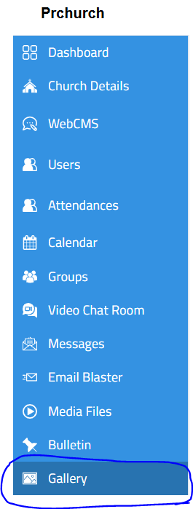
- Click the New Album button.
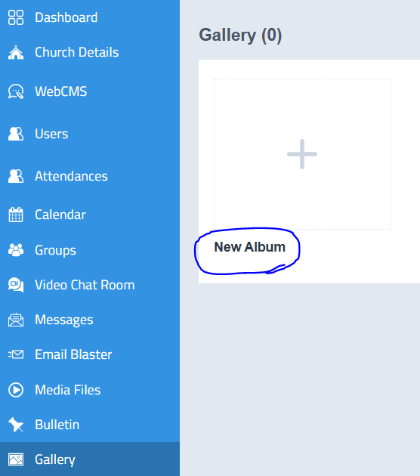
- Enter the required details:
  - Gallery Name
  - Cover Image
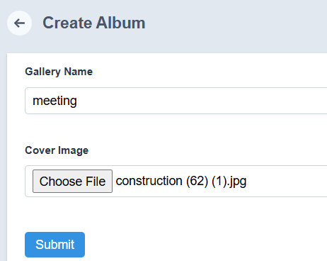
- Click Submit.

Outcome
- A new gallery album will be created successfully.
- The album will be listed in the Gallery section.

How to Edit a Gallery
- Navigate to the Gallery section.
- Locate the required album.
- Click the Edit option on the right side of the album image and change the cover image if required
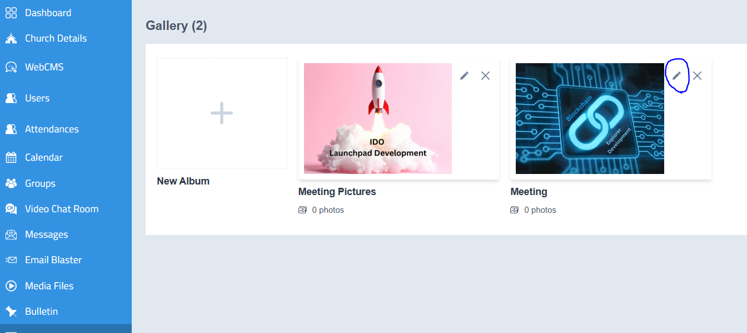
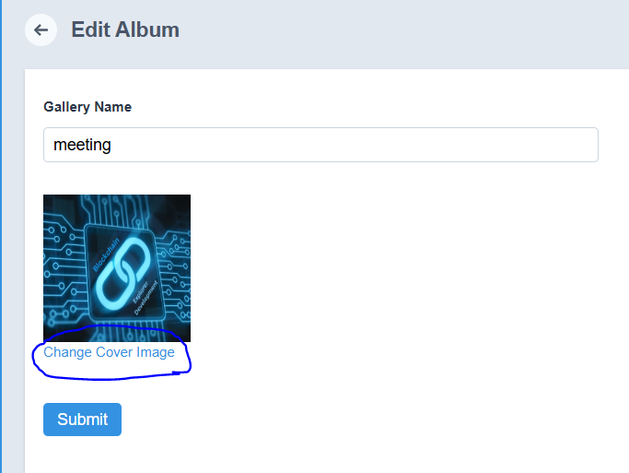
- Update the necessary details.
- Click Submit to save the changes.

Outcome
- The gallery details will be updated successfully.

How to Delete a Gallery
- Navigate to the Gallery section.
- Locate the required album.
- Click the Delete (✖) icon on the album.
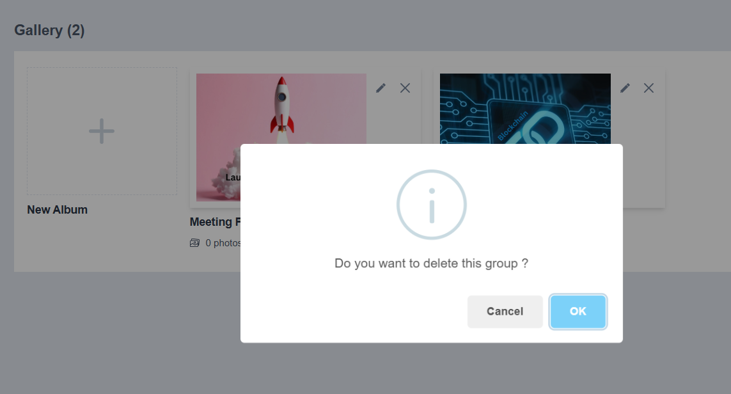
- A confirmation message will appear.
- Click OK to confirm deletion.

Outcome
- The gallery album and all images within it will be deleted permanently.

Notes
- Deleting a gallery will remove all associated images and cannot be undone.
- Ensure correct selection before deleting any album.

